Chapter 4, Problem 25.

Obtain v_{o} in the circuit of Fig. 4.93 using source transformation. Check your result using PSpice.

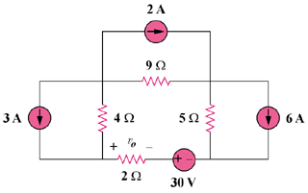

Figure 4.93
For Prob. 4.25.

